Summer School Applications
Please be advised that you do not have to provide your free and reduced Food Services letter when registering for summer school. The summer school office will verify each reduced fee application and consult directly with families, if necessary.

Spring ASE Season is Underway!
We are excited to start our Spring Session of After School Enrichment (ASE) programs. We are sponsoring over 20+ sessions in the following categories:
Academic Enrichment Sports
We hope all Randolph Stars sign up to attend at least one ASE program. Some ASE programs will begin the week of March 13th (permission slips were provided at P/T Conferences) and more will begin on March 20th (permission slips were sent home on Monday March 6th). We have 350 total student spaces available! Don’t forget to send your selection form and permission slip in by Monday, 3/13/17. Don’t miss out on the fun!

C-R-E-A-T-I-V-I-T-Y is the Word…
for our IB attitude of the month. Creativity is being able to create new and original things and using imagination. In school, students use creativity in art and music weekly. However, creativity applies to more than art and music. Creative thinking can be applied to math problems, reading strategies, or learning a new language. Scientists have to be creative to solve problems and test hypotheses. There are many ways to develop the attitude of creativity, such as writing poetry or stories, making art, learning a new song, or thinking about a math problem in a new way. Encourage your child to think creatively about situations at home.

Cooperation Prevails Among Our Students
Last month our school-wide focus for our IB attitude was on cooperation. Throughout our school, we focused on strategies to support each other and work together. We are very proud of our students and their commitment to working together by collaborating and sharing their points of view. The following students were recognized this week for their outstanding job in exemplifying “cooperation” throughout the month of February:
Pre-K
Yosias Abraham
Ashton Jackson
D'Anna Paz
Kindergarten
Hamza Ahmed
Harold Martinez Cardosa
Kenia Vigil Guevara
1st Grade
Pryanshu Barua
Kaylee Gochez-Hernandez
Nusrat Hossain
Erika Soto Sanchez
2nd Grade
Ariana Hernandez-Benitah
Farhan Lutfi
Cristhian Laguna Morales
3rd Grade
Hasna Abdelkarim
Jeremy Sejas Ayala
Victoria Peche Vargas
4th Grade
Nyla Davis-Thornton
Alif Rafi
Anania Tadesse
5th Grade
Colby Ames
James Bissett

Read Across America Day = We Books!
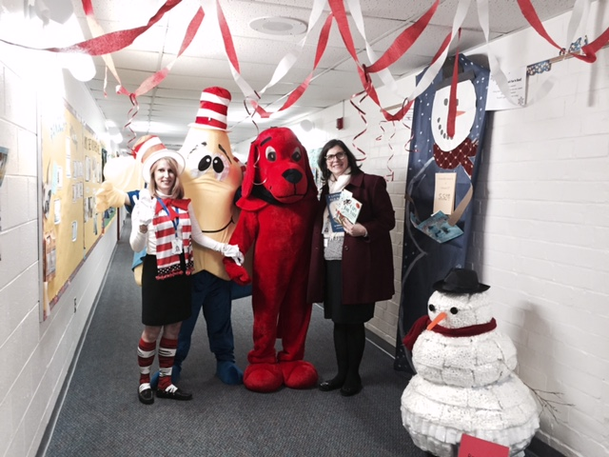
Our 2017 Read Across America Day on March 2nd was a huge success! We are very appreciative of the more than 30 community and APS staff members who served as guest readers for our Randolph Stars! The day was extra fun with classroom visits by Clifford, the Big Red Dog and Randy, the Randolph Star! Photos from our exciting day will be posted on our website.

Have You Signed Up Yet?
It’s not too late to register for the “Whole Child” Conference, which will be held on March 16th from 5:30-9:00 p.m. at Washington-Lee High School. Parents, students (grades 5-12) and staff will explore topics such as
- Love the Skin You’re In: A session for girls and young women and their parents
- Healthy Dating and Relationships
- Teen Stress
- Yoga and Mindfulness: An Interactive Workshop
- Heal Yourself: Healthy Eating and Active Living
- Personal Safety in Today’s World
- Creating a Culture of Respect for LGBT Students
- Ending the Silence: The Importance of Talking about Mental Health
- Teen Voices: The Truth About Substance Abuse and Middle School
- LUV: Listen, Understand and Validate – Building Trusting Relationships
- Coaching Boys Into Men
- A Community Conversation About Middle School and Substance
Registration can be completed online through the following link: https://www.apsva.us/whole-child-conference-2017/

Planning for Your Child’s Future Begins Now
Superintendent Dr. Pat Murphy and Arlington Public Schools (APS) welcome all APS students & families to explore students’ individual interests, plan for their future & connect with counselors & career professionals. On April 1st from 9:00 a.m.-2:00 p.m. at Wakefield High School, students and families are invited to:
- Participate in fun career exploration activities
- Explore personal interests and create academic/career goals
- Meet professionals with common interests and learn how to prepare students for a successful future
Registration is required. Lunch will be provided. To register or for more information visit: www.apsva.us/createurpath Individuals will be available to assist with Spanish interpretation.

Dust Off Your Old Books…
and consider donating them to the PTA’s 4th Annual “Book Grab” on Friday, March 31st. Donation drop box locations:
- Randolph Elementary Main Office
OR
- Call Susan at 813-422-8431 for pick up

It’s “Snow” Much Fun to Read
Have you seen our Randolph snowman in the main hallway? It has grown to over 6,000 snowballs, representing books read by Randolph students! Our goal is to reach 10,000 snowballs! Keep encouraging your child to read and send in their recording sheets.

Umm… The Coffee Smells Delicious!
We’ve opened a new can of coffee, purchased some fresh Danish and fruit, and are inviting all parents and guardians to join us at the next “Principal’s Coffee” on Friday, March 17th at 8:30 am in the library. In addition to spending time getting to know one another and having time for an open question/answer period, we will also spotlight our literacy strategies that can be easily used at home for pre-kindergarten aged students.

Kindergarten Visitation Parent Coffee
Please share this information with neighbors related to our upcoming “Kindergarten Information Sessions.” These sessions enable parents and guardians to visit the school, meet the administrators, tour the building, see the schools “in action” and get a general sense of the personalities of the school. Our information sessions will be held on March 14th at 12:45 p.m. and April 6 at 9:15 a.m. We hope to meet all parents of rising kindergarten students and share our instructional program with them!

Our First PreK-5 Yearbook is Underway!
We are so excited to share the news about the design of our inaugural PreK-5 yearbook. Under the leadership and guidance of Leila Vega, one of our talented instructional assistants, our upper grade students are creating our school-wide yearbook. With the After School Enrichment (ASE) program offerings, many students selected the “Yearbook” as one of their clubs. They work diligently each week on the various components of creating a polished and comprehensive yearbook! As we plan for upcoming candid shots to be included in the yearbook, please let us know by Friday, March 17th if your “Opt-out” preference has changed from the beginning of the school year. We have the school-wide “Opt-out” list where the yearbook is included as one of the opt-out choices. If you would like to change the status of your opt-out for the yearbook, please let the office know by calling 703-228-5830 or sending a note to Dr. Snyder. If we do not hear of any changes, we will adhere to the selections made by families in September.

UPCOMING EVENTS
March 12: Daylight Savings Time (MOVE CLOCKS FORWARD 1 HOUR!)
March 13: Club de Madres, 8:15-9:30 a.m., Arlington Transportation Options, Library
March 13: PTA Fundraiser at Chipotle, 5:00-9:00 p.m.
March 14: Kindergarten Information Session #1: 12:45-2:15 p.m.
March 14: PTA Meeting, 7:00 p.m., Library
March 15: 3rd grade field trip to Brookdale Arlington Senior Living, 10:15-11:30 a.m.
March 17: St. Patrick’s Day
March 17: Principal’s Coffee – Pre-School Literacy Strategies, 8:15 a.m., Library
March 17: Math Dice Competition (grade 5), 9:35-10:40 a.m.
March 20: Club de Madres, 8:15-10:15 a.m., Cafeteria: Conscious Discipline Part 3, PreK-5
March 20: Conscious Discipline Part 3, 8:15-10:15 a.m. (PreK – 5 parents), Cafeteria
March 21: Conscious Discipline Part 3, 6:30-8:00 p.m. (PreK – 5 parents), Library (light refreshments at 6:00 p.m. in cafeteria)
March 27: Club de Madres, 8:15-9:30 a.m., Library
March 31: PTA Book Grab
March 31: Pre-K field trip to Planetarium, 10:30 a.m. – 12:00 p.m. (Donnelly/McGuire)
March 31: Pre-K field trip to Planetarium, 12:30-2:00 p.m. (Montemayor/Willis)
March 31: Randolph Student Art Work Sale (details forthcoming)

