Young Author’s Day:
Randolph’s annual Young Authors and Illustrators’ Conference is scheduled for Friday, October 14. There will be a full day of literacy events including presentations by keynote authors, Carole Boston Weatherford (grades 2-5) and Hena Khan (grades preschool – 1). Students will receive an autographed copy of either Golden Domes and Silver Lanterns by Hena Khan or Freedom on the Menu by Carole Boston Weatherford. Randolph families and friends are invited to attend presentations by both authors. Look for a detailed flyer that will go home with students at Parent Teacher conferences on October 6 and 7.

We’re looking forward to seeing you at your Parent-Teacher Conference this week! Together we are core partners in the learning process. This week’s conference is an opportunity for you to learn about your children’s progress in school and for our teachers to gain insights into students’ interests, hobbies and learning styles. According to the “Harvard Research Project”, Harvard Graduate School of Education, the following principals for effective conferences are suggested:
B est intentions assumed
E mphasis on learning
H ome-school collaboration
E xamples and evidence
A ctive listening
R espect for all
D edication to follow-up

October is National Bullying Prevention Month
National Bullying Prevention Month is a nationwide campaign founded in 2006 by PACER’S National Bullying Prevention Center. Students who are bullied can:
- Report bullying at school to teachers, school counselor, or the principal
- Talk to a trusted adult at home
- Calmly say, “Stop it.”
- Walk away
- Be assertive, but do not get into a physical or verbal fight
- Hold your head up and show confidence in yourself
- Use humor
- Stick with a friend whenever possible
- Avoid the bully

Resources:
- Check with the school counselor & visit the bullying page on the APS website
- www.stopbullying.gov
- http://pbskids.org/itsmylife/friends/bullies/
- http://www.stompoutbullying.org/

From the School Counselor, Jennifer Baitinger:
Students will be given 2 lessons on bullying, which will include reporting bullying. Did you know there are resources about bullying on the counseling tab of the Randolph website? Please check it out. If you ever have any concerns please let your teacher or me know. Also, follow me on Twitter: @RandolphstarsSC

Fall Clean Up Day

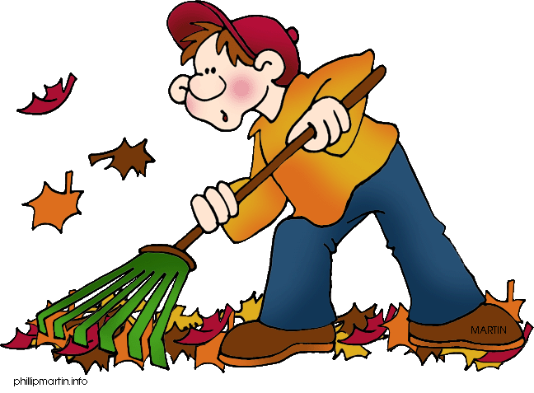

Date: | October 22, 2016
Time: | 9:00 a.m. – 12:00 p.m.
Where: | Randolph Elementary School
Who: | Family and Community Members of Randolph Elementary
What: | Come out and join us in helping keep our school community beautiful! Mulching, weeding, planting, raking, trash pick- up. Something for everyone to do.
How: | Show up at the front of the building on 10/22 wearing your yard-working clothes. Bring gardening gloves and hand tools (if you have them). We have some tools and will have the supplies needed to keep our school beautiful.

October 6-7: Parent-Teacher Conference (No school for students)
October 10: Columbus Day Holiday – No school for students and staff
October 11: Individual Picture Day
October 14: Young Authors and Illustrators’ Day: Parents are welcome to attend
October 14: Hispanic Heritage Evening: Kenmore Middle School, 5:30-9:00 PM. Bus transportation provided. For more information, please contact Jackie Garcia at 703-228-8193.
October 26: 8:30 am Principal’s Coffee
October 26: Early Release Day – Students released at 12:51 PM

