Parent Advisory Committee is Looking for You!
Our school is committed to developing strong partnerships with parents. Parents and schools working as partners increase student achievement and help develop positive attitudes about self and school. Our “Parent Advisory Council” is established in the fall of each school year. This committee meets periodically through the school year to discuss our school management plan and help shape new initiatives. We are currently seeking two additional representatives for the 2016-17 school year. Meetings will be held at school from 4:00-5:15pm. If you would like to serve as one of our representatives, please call our main office at 703-228-5830 and leave your contact information. Together, we’ll shape the future for our children.

Drum Roll Please…
After much discussion, dialogue and feedback from our entire Randolph community, we are pleased to share our Randolph Elementary School mission and values (see attached). Serving to guide our collective vision for our school, our mission and values speak to our beliefs, attitudes and commitments to educating our children.

Join Us This Evening at Kenmore Middle School

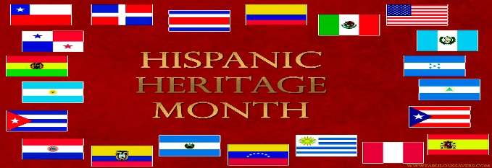

We’d love to have you join our Randolph family as we unite with other APS schools to celebrate Hispanic Heritage Month. This year’s theme, “Harvesting Dreams for Our Children: Opportunities for a Successful School Journey” will highlight resources, ideas and new connections to help children excel. This engaging event will be offered in Spanish with English interpretation. Interested families can meet us at Randolph at 5:00pm to travel together on a school bus or meet us at Kenmore Middle School at 5:30pm.

Living Our International Baccalaureate (IB) Principles:
We’re proud to serve our larger Arlington community with our Annual “Walk to End Homelessness” on October 31st. Uniting together in our support to assess those in need, provides our children with opportunities to apply our IB principles of empathy, sensitivity and tolerance. If you would like your child to participate in our neighborhood walk, please be sure to sign the permission slip that was given to you at the Parent-Teacher Conference.

Enrichment Excitement is Building!
We are pleased to be offering a wide range of After School Enrichment (ASE) programs which focus on fitness, arts and academic enrichment. Our fall session of enrichment experiences will operate from the week of November 7 through December 15. Detailed information on our inaugural ASE is attached to this newsletter. Sessions will fill quickly so please return the permission slip if your child is interested in participating. We’re looking forward to extending learning through engaging educational and fun after school experiences.

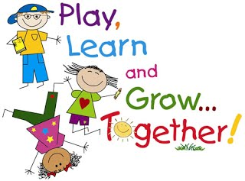

IB News:
We have had a great start to our year with our IB PYP units. Several units are being rewritten this year due to the changes in the Virginia social studies curriculum. As we work through these changes, please know that our units are in transition.

The following units are currently being taught at each grade level:

Grade Level | Unit | Central Idea/Content
Pre-K | How We Express Ourselves: Tell Me All About | We can express ourselves through actions and words to tell and show others how we feel, what we know, and what we can do.
Kindergarten | Who We Are: I’m Me and Here’s Why | Each person is unique and has a role in the school community. (study of characteristics of a good citizen, graphing)
1st grade | Who We Are: Meet Your Neighbor | People all over the world are the same and different. (study of characteristics of a good citizen, map skills, and Virginia government)
2nd grade | How we express ourselves: The World Through Our Eyes | As citizens, we use observations and tools to learn about our world. (study of scientific investigation, matter, magnets and civics)
3rd grade | How we express ourselves: New Unit being rewritten | Rewriting central idea. Students are learning about the scientific method and the role of good citizens.
4th grade | How We Organize Ourselves: I Will Survive | People’s culture is impacted by their physical environment. (study of Virginia regions, American Indians, science investigation and weather)
5th grade | How We Organize Ourselves: Does It Really Matter? | Systems develop in response to outside influences. (study of matter and atoms, prehistory)

Upcoming Events

October 17: Monday Morning Mom’s (and Dad’s) Club – All parents are welcome! 8:30-10:00am

October 19: “Stop Bullying Day” – Wear Orange Day

October 19: Grade 4 “Helping Hands” Day

October 22: Community Clean Up Day, 9:00am – 12:00pm

October 25: Grade 1 field trip to Planetarium, 9:15-10:45am (Henry/Kowalevicz); 12:30-2:00pm (Cain/Tiegerman/Weber)

October 25: Grade 3 field trip to Planetarium, 10:30am – 12:00pm (DeLeon)

October 26: Grade 4 field trip Planetarium, 9:15am-10:45am (Baker/Gillen)

October 26: Grade 1 field trip to Brookdale, 10:15-11:30am
October 26: Monthly Principal’s Coffee, 8:30-9:30am

October 26: EARLY RELEASE at 12:51pm

October 27: Grade 3 field trip to Planetarium, 9:15am-10:45am (Hall/Merritt)

October 27: Grade 5 field trip to Planetarium, 10:30am – 12:00pm (Martin)

October 27: Grade 2 field trip to Planetarium, 12:30-2:00pm (Harrington/McNally)
October 28: Pre-K students to Burke Pumpkin Patch, 9:30am – 1:30pm

October 28: Grade 5 field trip to Planetarium, 10:30am – 12:00pm (Eskenas/Freeland)

October 28: Grade 2 field trip to Planetarium, 12:30-2:00pm (LeVault/Ryan)

October 28: Halloween Sock Hop, 6:00-8:00pm, Gym

October 31: Grade 4 field trip to Planetarium, 9:15-10:45am (Reichenbaugh)

October 31: Halloween and Walk to End Homelessness Neighborhood Walk, 2:00pm

